Solar Water Desalinator and Purifier Machine

Only 3% of the water available on earth is fresh water. Two thirds of this fresh water is present in frozen glaciers. On an average over 1.1 billion people over the globe lack proper access to any fresh water reserves and over 2.7 billion people face scarcity of water at least once a month. But fortunately as we know 71% of earths surface is water and 97% of that water is sea water.
So here we develop a portable solar powered se water desalination as well as water purifier to solve the water problem with a smart innovative concept. The solar portable desalinator serves the following key aspects
- Fast Water Desalination
- Instant Purification of desalinated water using RO system
- Added UV sterilization for virus bacteria sterilization
- Compact Design
- Portable Design Easy to Move
- Solar Powered – No External Power Needed
- Easy Maintenance System
The machine makes use of a 3 stage process to convert salty seawater to pure drinkable water. The system first allows user to pour salty water via a mesh based inlet where large waste like plastic granules or stones, weed etc gets separated. This water is then pumped into a large purification chamber having 3 layers of purifiers including sand and gravel for filtering weed, sand and large salt particles.
The output of this process is still salty water but without any particles. This water is then passed on to the second filtration where we use reverse osmosis to filter out salt from the water. Here we use 3 filtration membranes to filter out fresh water from salty water and trap the salt particles in membrane filters.
This water is now stored in a tank just above the system. The system tap when opened allows water to run from the tank to the tap where we detect the flow when on and turn on the UV light for stage 3 filtration to deactivate any remaining bacteria and virus in the water. This water is now in drinkable form using 3 stage process without the use of any chlorine.
Now the pumps used in the system are powered by a large battery. This battery is in turn charged by 2 x 50Watt solar panels due to large availability of solar power in sea areas. This makes it very portable to be used on any beach front or on long sea voyages for easy and instant sea water filtration.

Components:
- Solar Panels
- Water Tank
- Stage 1 Purifier Vessel
- Water Pumps
- Electrical Circuitry
- UV Tube
- Membrane Filters
- Steel Tap
- Steel Handle
- Piping
- Pipe Fittings
- Nozzle
- Pipe Connector
- Battery
- Hinges
- Supporting Rod Pipes
- Protective Mesh
- Monitoring Glass
- Mounts and Joints
- Base Frame
- Supporting Frame
- Screws and Fittings

Advantages:
- Ability to Purify Seawater
- Solar Powered | No External Power Needed
- 3 Stage Purification
- 4 Wheel Portable Design
- Quiet Operation
- Easy To Use

Disadvantages:
- Has limited filtering Capacity
- Seawater to be manually fed into the machine
- Requires timely Maintenance

Block Diagram

Front View
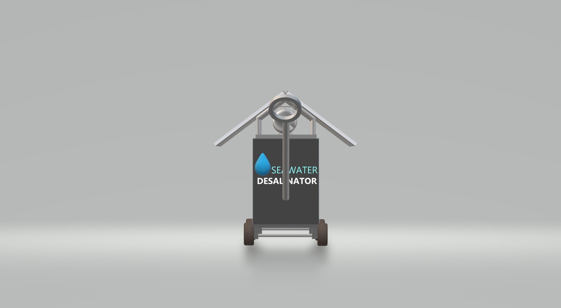
Side View
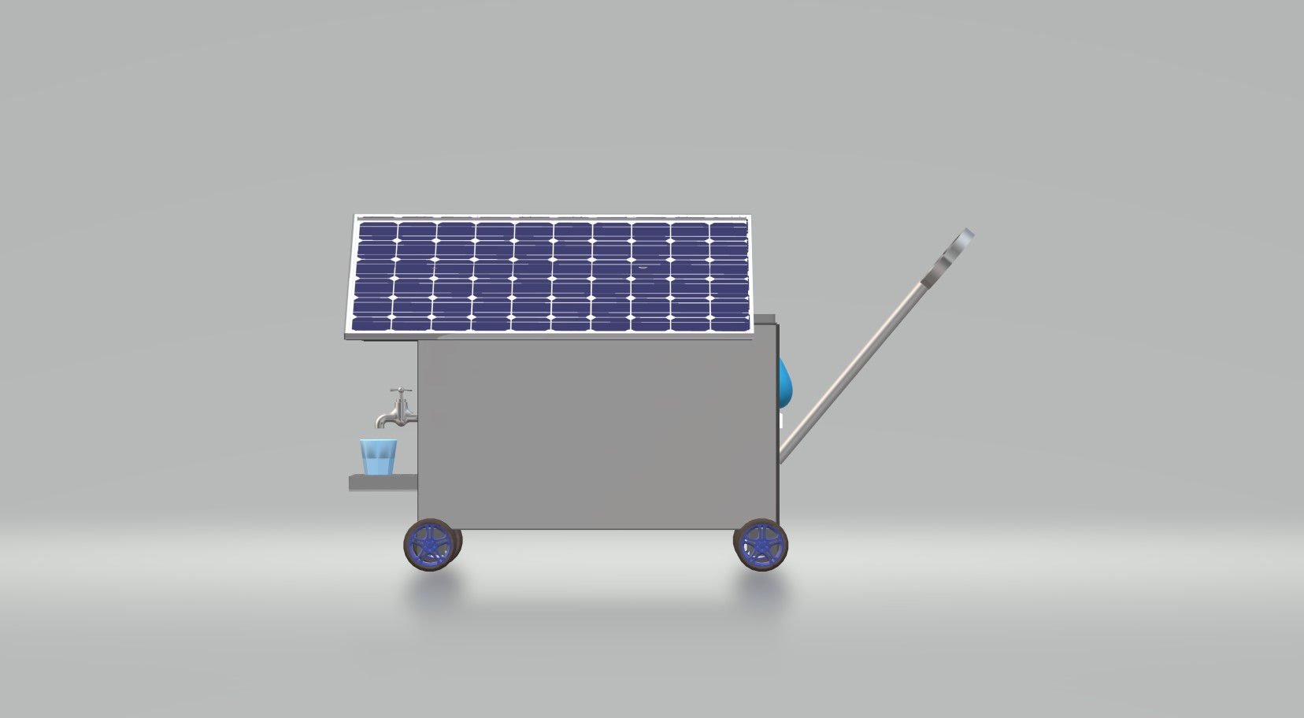

3D View
